**8-BIT SUBTRACTION**  
**EXP NO: 2**  
**AIM:**To write an assembly language program to implement 8-bit subtraction using 8085 processor.   
**ALGORITHM:**  
1)      Start the program by loading the first data into the accumulator.   
2)      Move the data to a register.  
3)      Get the second data and load it into the accumulator.   
4)      Subtract the two register contents.   
5)      Check for borrow.   
6)      Store the difference and borrow in the memory location.   
7)      Halt.   
**PROGRAM:**  
          LDA 8000   
          MOV B, A   
          LDA 8001   
          SUB B   
          STA 8002   
          RST 1 **:**

INPUT:

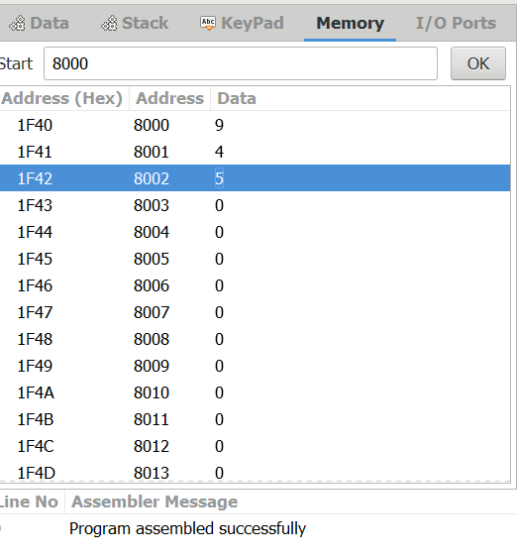

OUTPUT:

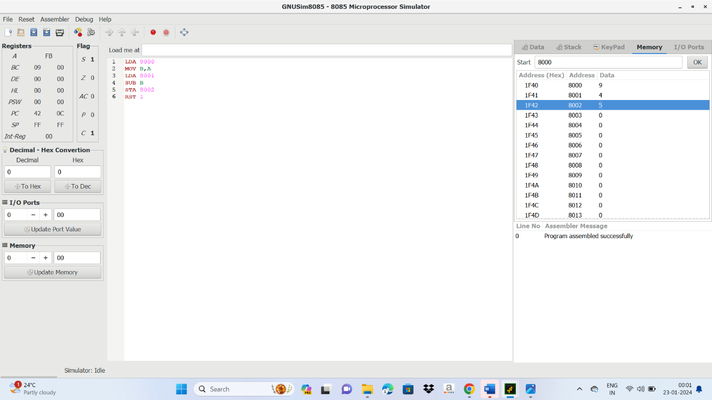

RESULT:

Thus the programmer has been executed successfully using 8085 processor simulator.